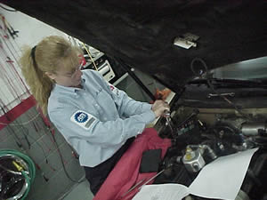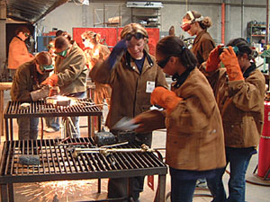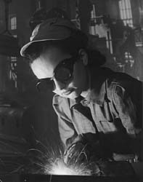
CALWOMENTECH TRAINING

LAS POSITAS COLLEGE
February 25-26, 2008
9:00am to 5:00pm

As part National Science Foundation (NSF) Grant administered through the Institute for Women in Trades, Technology & Science (IWTTS) based in Alameda, Las Positas College Automotive and Welding Programs have been selected to participate in the CalWomenTech project for the next four years.

The goal of the grant is to recruit and retain women into fields that they currently are under represented in. Automotive and Welding at Las Positas College fall into that category, not surprisingly to most. The truth of the matter is, there are great opportunities out there for women in both fields, and it is that we are often overlooked in favor of something more appealing to 50% of the population; that is the basis for the grant.

Reversing that trend is what we aim to do.

As part of the support we will receive, IWTTS will be coming to LPC to provide two full days of training. As part of our commitment to the program, we said we would have a significant portion of our campus leadership team attend. Your participation in this event is important, both to Automotive and Welding, but to the LPC campus, and community as well. While the day’s events will be focused on recruiting and retaining women into Automotive and Welding, much of what we will learn can be applied to other areas and fields as well. The IWTTS message was:

2-day WomenTech Recruitment and Retention Training
This onsite training will be presented by Donna Milgram, and will include the development of your own Recruitment and Retention Plan. The CalWomenTech Leadership Team members are required to attend. Additionally, we recommend you invite any other instructors or faculty that would benefit from the training and could help with the plan.

The training is split into a morning and afternoon session, with information from Donna Milgram in the morning, followed by a working lunch, with the afternoon being devoted to developing implementation plans for Automotive and Welding. There will be discussion and training on the collaboration software used during the life of the grant and program here at LPC. Each day will start out with some light breakfast snacks. Please respond if you can attend to Scott Miner before February 8, 2008. We really want you to help us recruit and retain women in Auto and Welding!!

You can be part of something we have never done at Las Positas College before!

If you are interested and would like to attend, please RSVP to Scott Miner (sminer@laspositascollege.edu) before February 8, 2008

